Manual Excel Data Cleaning Guide (Step-by-Step)

1. Clean Column Headers

- Rename headers to lowercase, remove spaces/special characters

- Double-click headers to edit.



2. Handle Missing Values

- Find blanks: `Data` → `Filter`, select blanks.

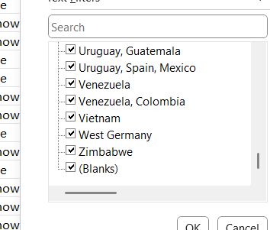

3. Remove Duplicates

- Go to: `Data` → `Remove Duplicates`.

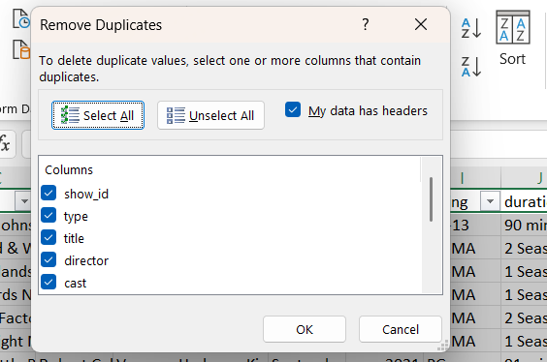

4. Standardize Text



5. Create Pivot Table

- Content by country: Rows=`country`, Values=`show_id` (count), Filter=`type`.

- Titles by year: Rows=`release_year`, Values=`title` (count).

- Duration frequency: Rows=`duration_type`, Values=`show_id` (count).



